EXERCISE NO. : 8

CLOSED LOOP PNEUMATICS

STATUS CONTROLLER

DATE:

Reg. No. :

**PREREQUISITE KNOWLEDGE:**

* Fundamentals of pneumatics and its basic components.
* Fundamentals of FluidSIM software for simulation of pneumatic and electrical circuits.

**OBJECTIVES:**

* + To be able to set the parameters of a status controller
  + To get familiarized with the influence of controller coefficients

**THEORY:**

**5/3 Proportional Valve**

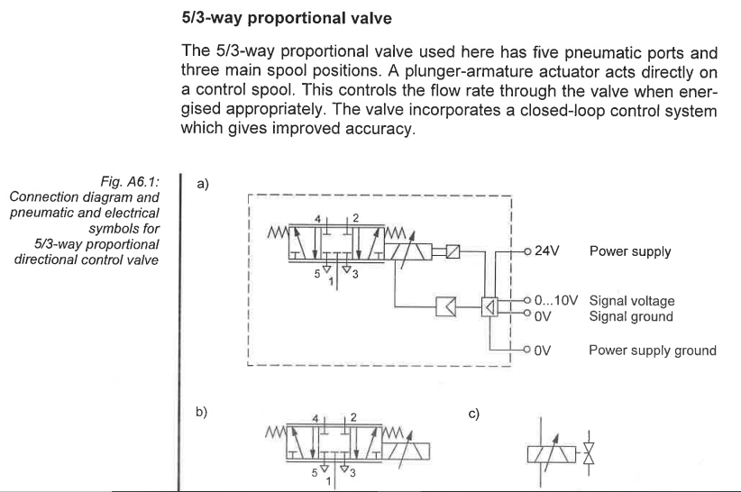

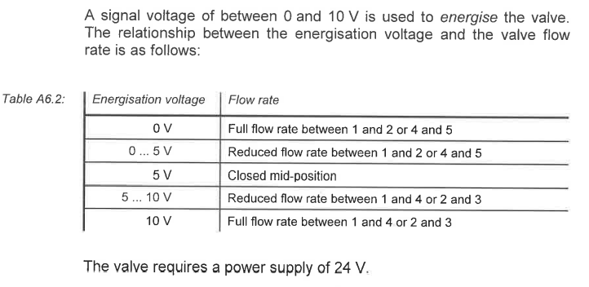

**Linear Potentiometer**

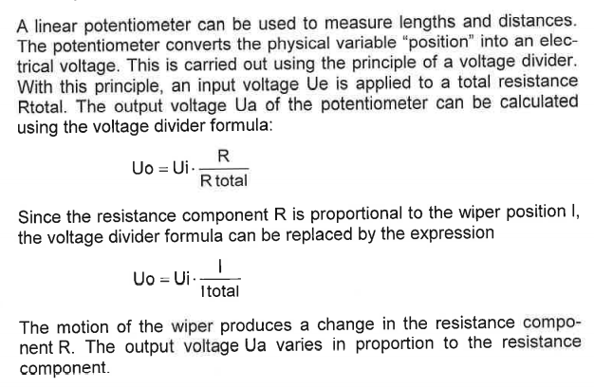

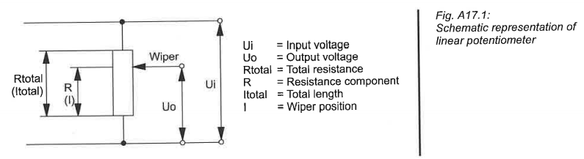

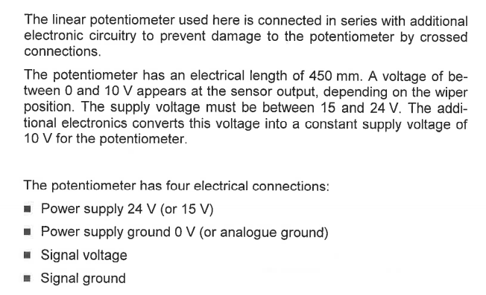

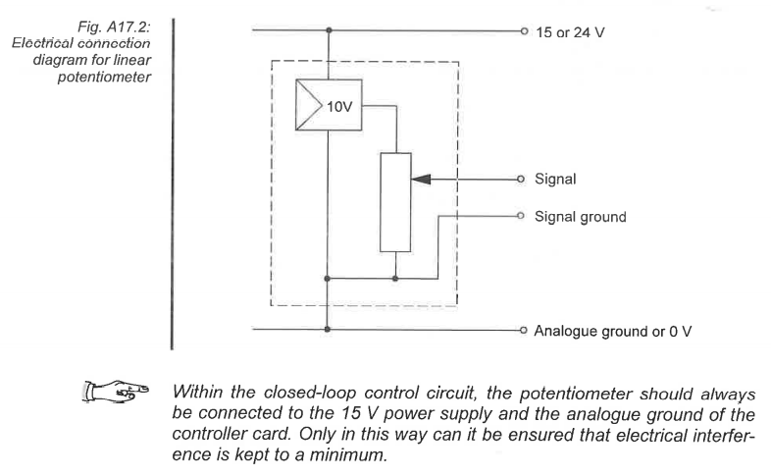

**Linear Axis (Rod-less Cylinder)**

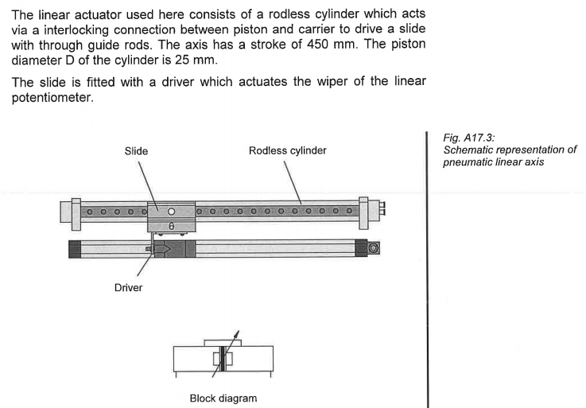

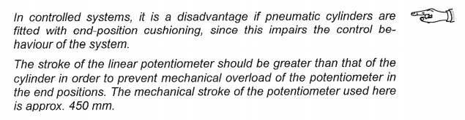

**Status Controller**

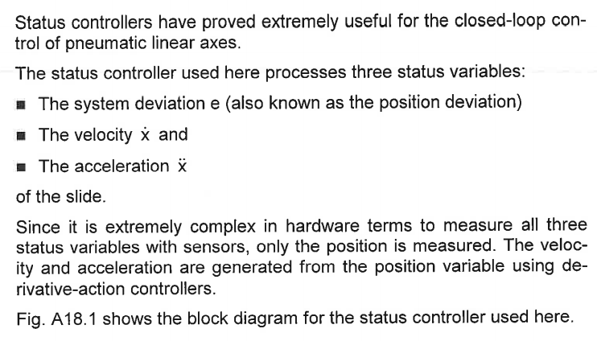

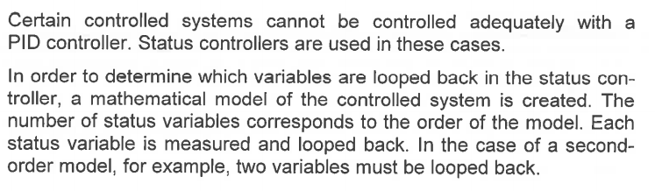

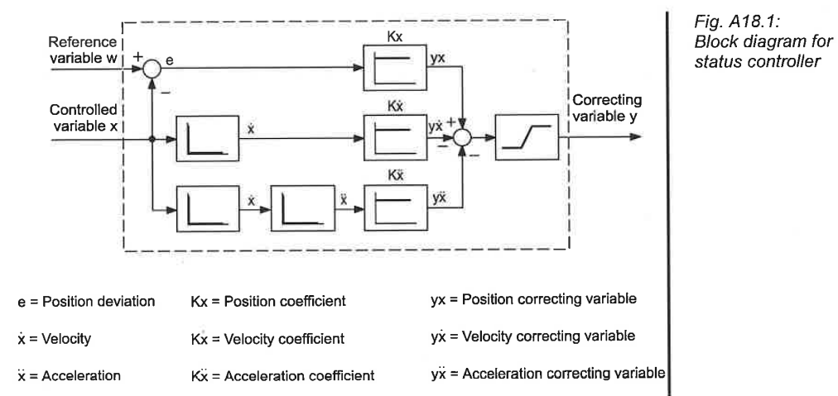

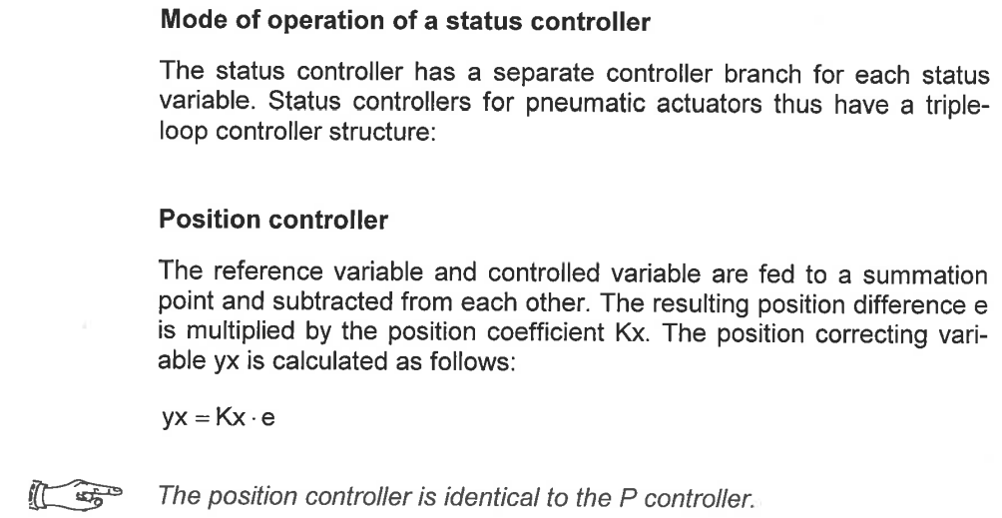

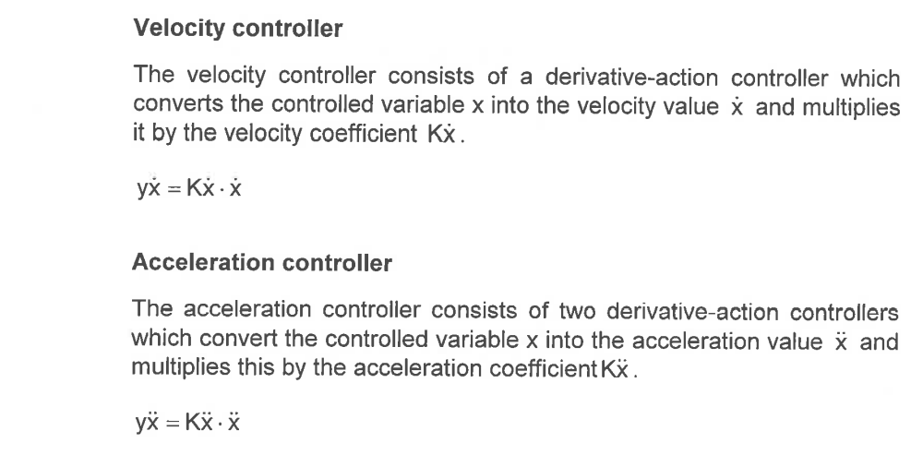

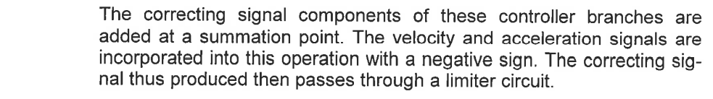

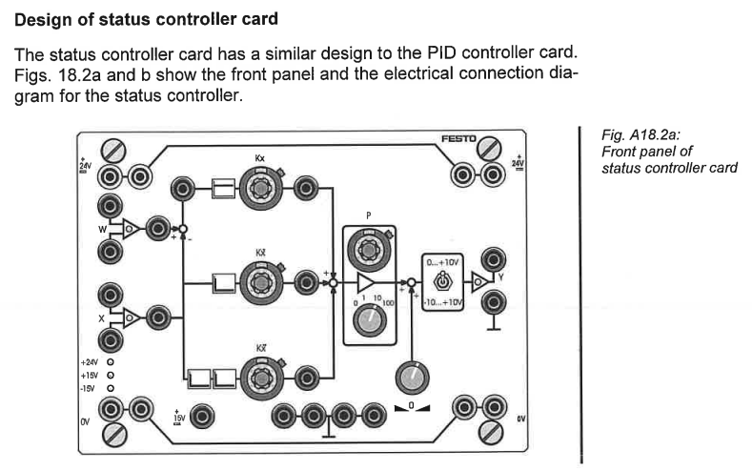

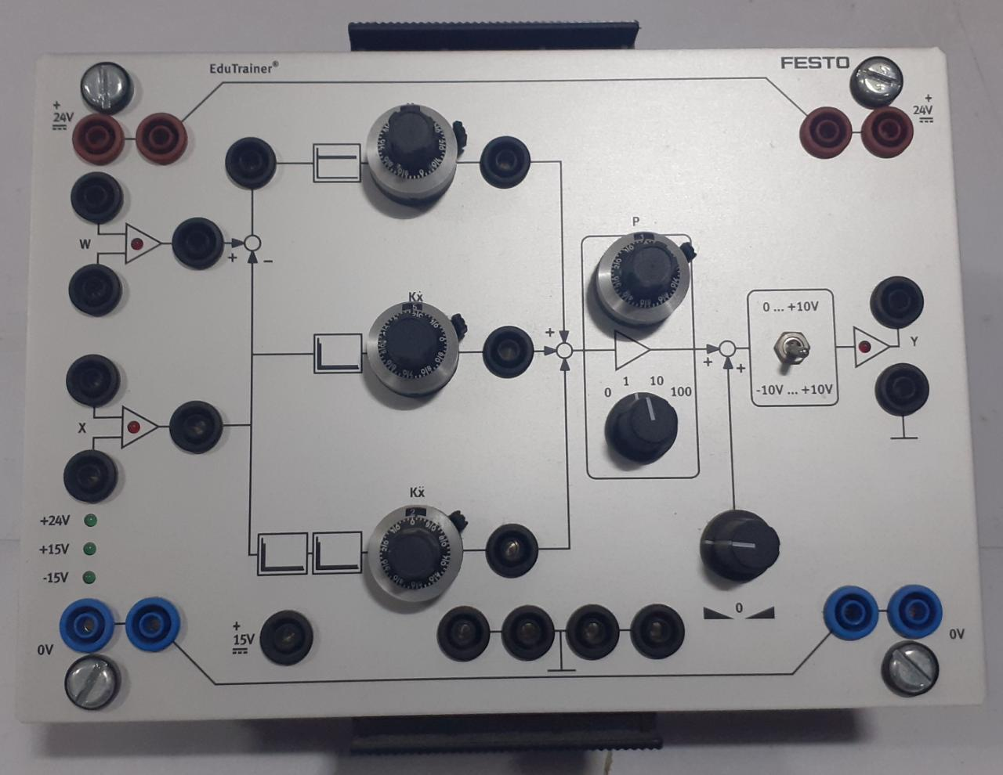

**Festo Status Controller**

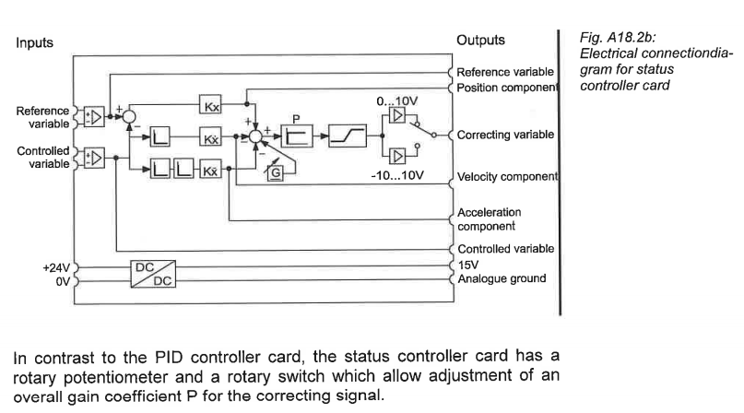

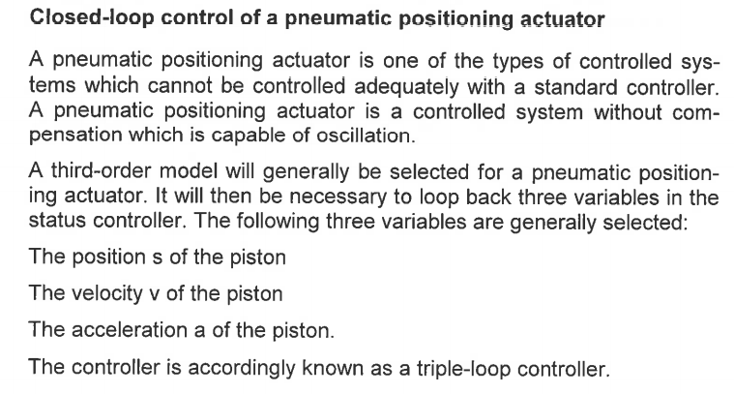

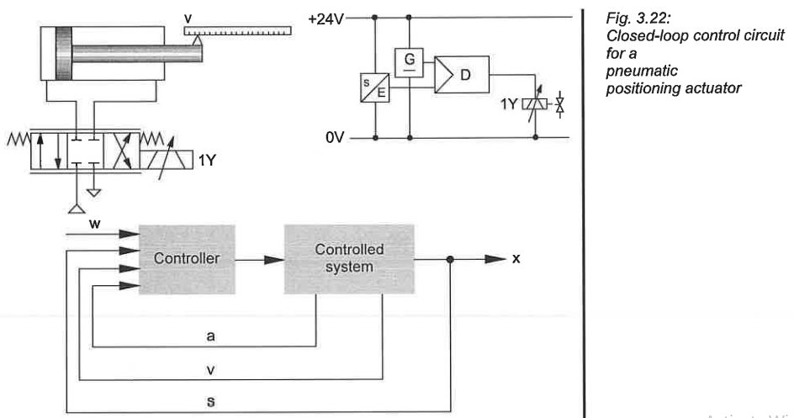

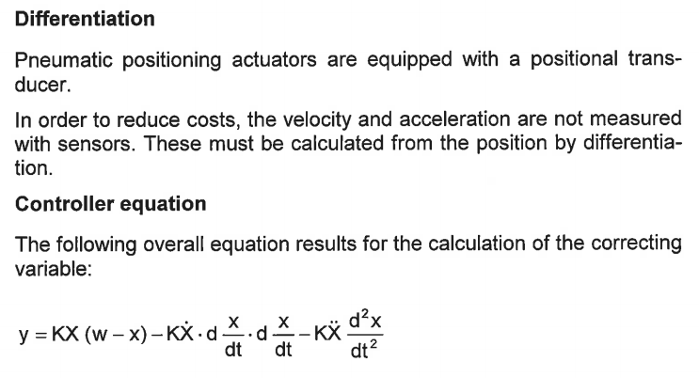

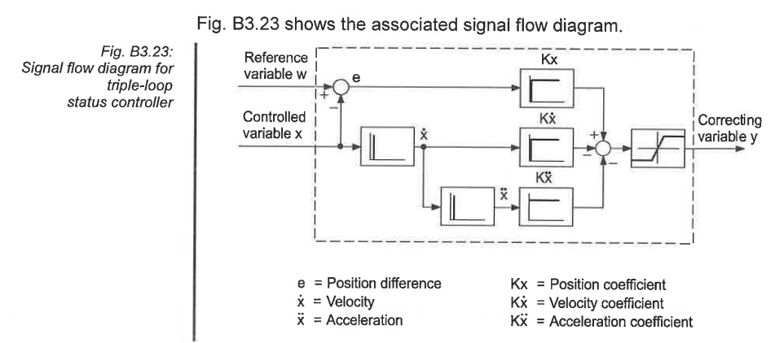

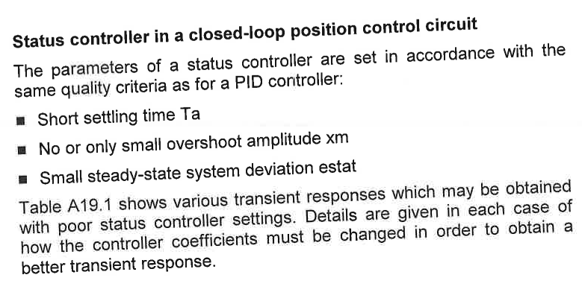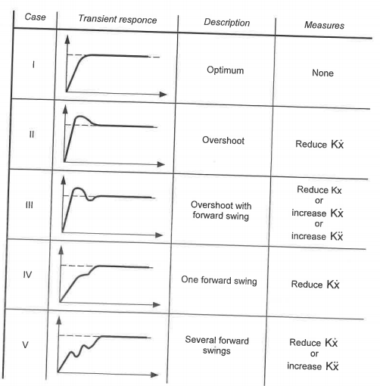

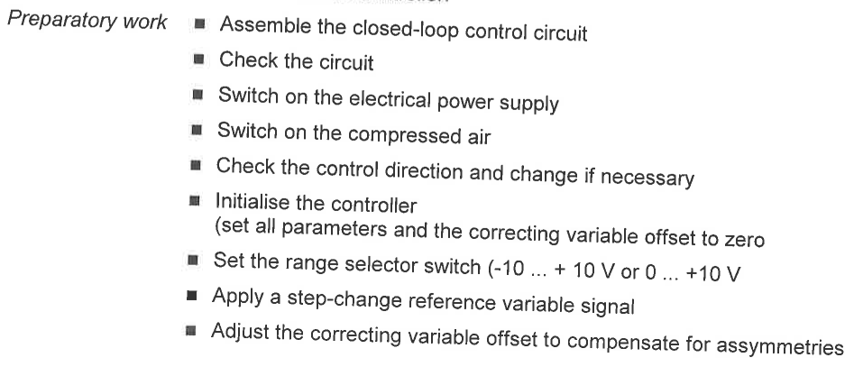

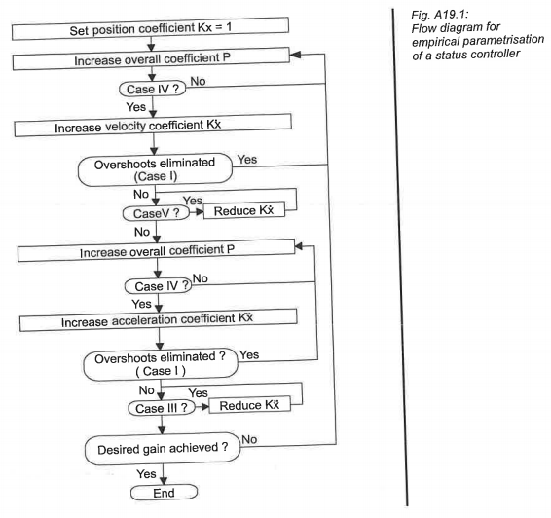

**TASK 1 – POSITION CONTROL OF A PNEUMATIC CYLINDER IN A DEBURRING APPLICATION**

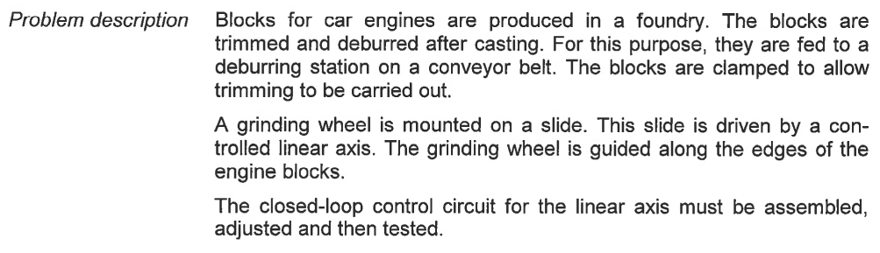

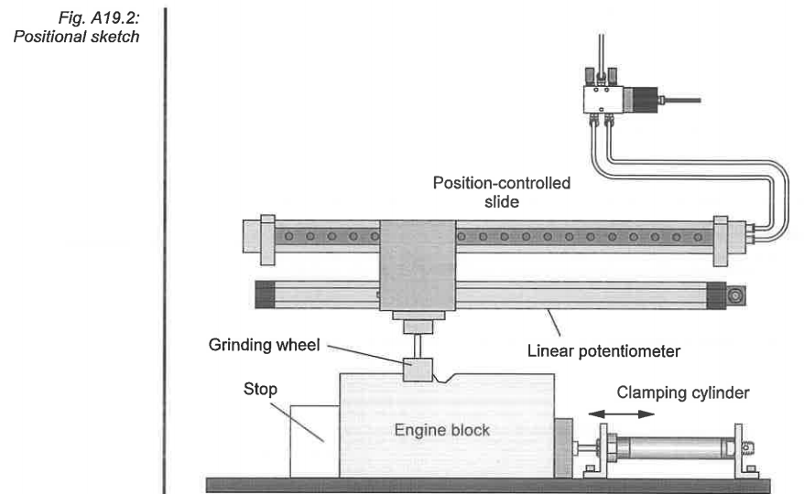

**Assembly and Commissioning of Closed Loop Circuit**

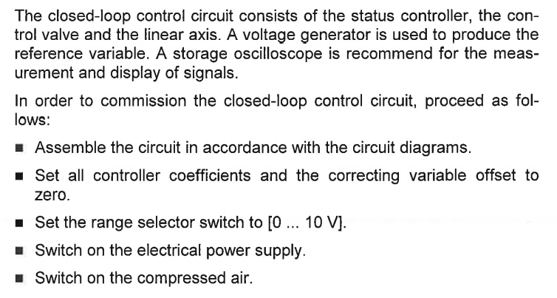

**Investigation of Transient Response for Various Coefficients**

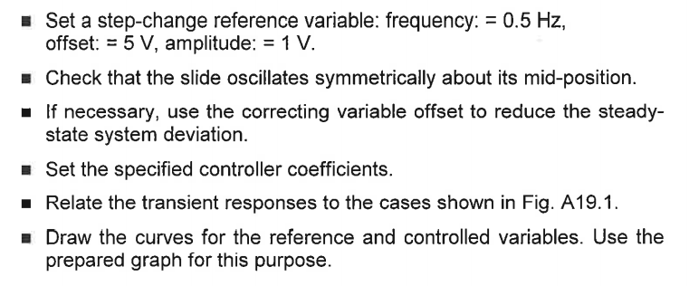

**Parameterization of the Controller Using Empirical Method**

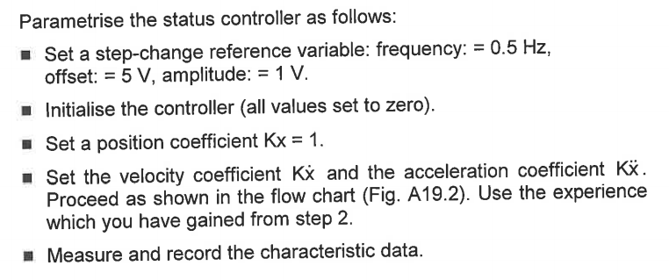

Use the following specifications for the rod-less cylinder

|  |  |
| --- | --- |
| **Specification** | **Value** |
| Type | Double acting cylinder, Piston rod-less cylinder with slide, Adjustable Cushioning |
| Stroke | 450mm |
| Piston Diameter | 25mm |

**DELIVERABLES**

**TASK 1**

* Pneumatic and Electrical circuit diagrams

|  |  |
| --- | --- |
|  |  |
| (a) Pneumatic Circuit Diagram | (b) Electrical Circuit Diagram |

* Investigation of the transient response for various coefficients.
  + Present the state diagram of the controlled variable for the following cases to understand the influence of the respective coefficients.
  + **Case 1**:

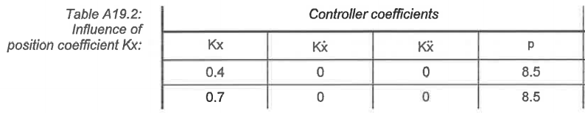

|  |
| --- |
|  |
|  |
| Case 1.1 – Overshoot with one forward swing |
|  |
|  |
| Case 1.2 – Overshoot with two forward swings |

* + **Case 2**:

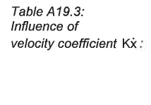 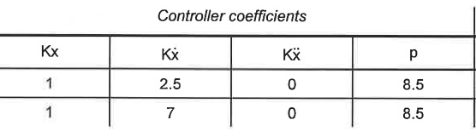

|  |
| --- |
|  |
|  |
| Case 2.1 – Overshoot with two forward swings |
|  |
|  |
| Case 2.2 – Overshoot with slight forward swing |

* + **Case 3**:

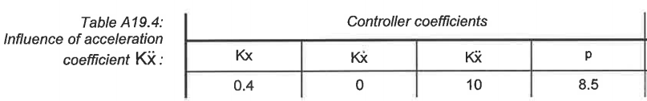

|  |
| --- |
|  |
|  |
| Case 3 – Overshoot with one forward swing |

* Parameterization of status controller using the empirical method. Note the values which have been set for the characteristic data to obtain a minimum or no overshoot, minimum steady-state error and quick settling time.

|  |  |
| --- | --- |
| **Characteristic Data** | Values |
| Overall Gain | 25 |
| Position Coefficient | 1.8 |
| Velocity Coefficient | 27 |
| Acceleration coefficient | 0.1 |

* Present the state diagram of the generator, displacement encoder and position of the piston.

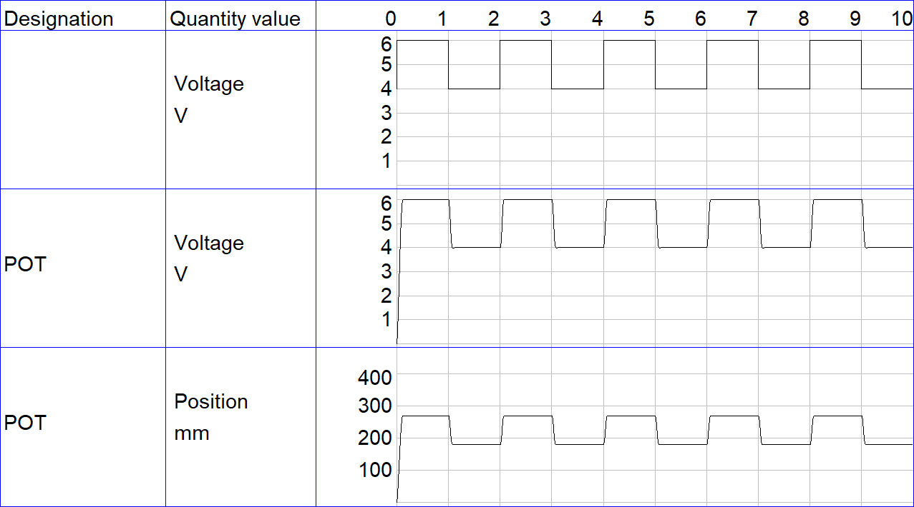

**LAB SESSION SCREENSHOT**

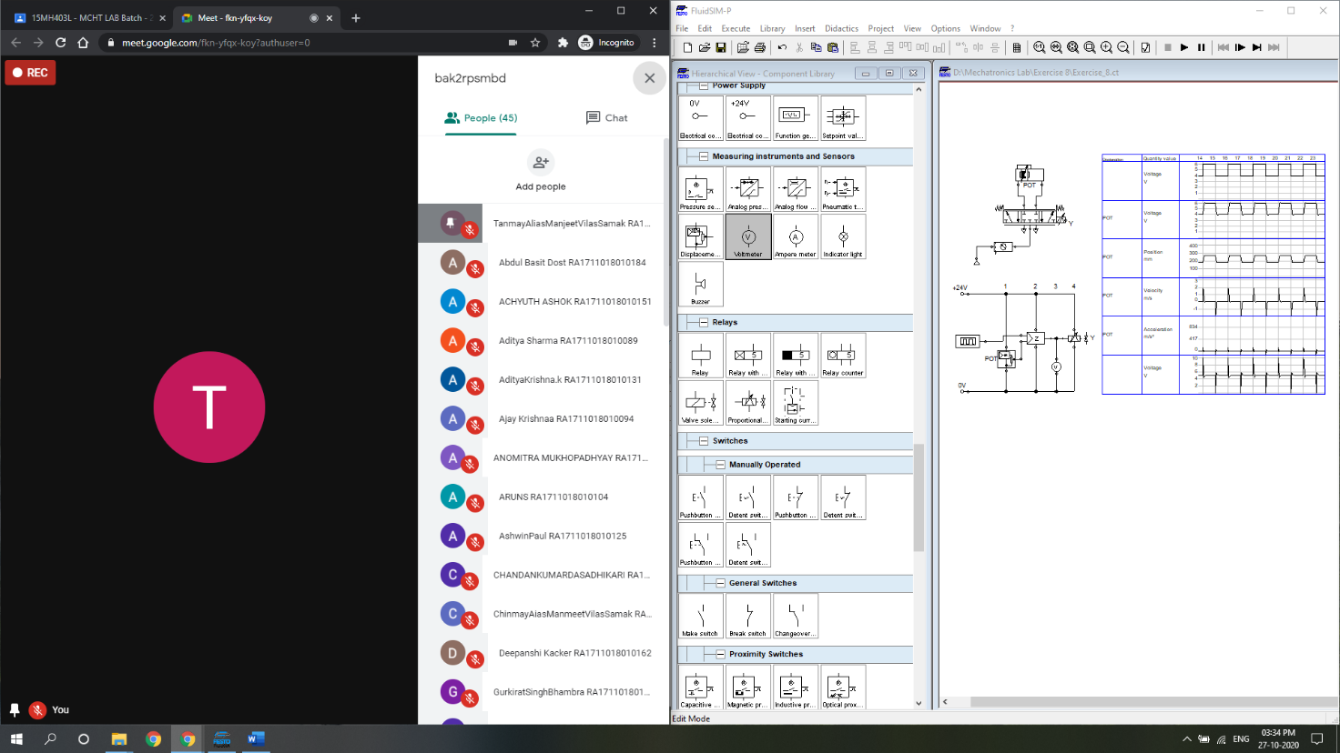

**INFERENCE**

The working of a proportional valve was studied from both theoretical and practical viewpoints. A closed loop electro-pneumatic circuit to control the position of a double-acting rodless cylinder was constructed and simulated using Festo FluidSIM.

The voltage setpoint to the solenoid of the proportional DCV was a square wave of frequency = 0.5 Hz, amplitude = 1 V, and offset = 5 V, to control the valve spool proportionately about its mean position (@5V). The signal generator voltage (input) was not directly comparable against the piston position of the double-acting rodless cylinder as the physical units of these two quantities were not identical. Nonetheless, the displacement encoder (linear potentiometer) output in terms of voltage was directly comparable against the signal generator voltage, since the two had same voltage scale.

The theory of status controller was understood and a simulated status controller was implemented to control the position of a double-acting rodless cylinder. The effect of position, velocity and acceleration coefficients , and respectively was analysed by observing the transient response of the controlled variable (piston position of the double-acting rodless cylinder). Finally, the coefficients were tuned to get minimum (or no) overshoot, minimum steady-state error and quick settling time. The coefficient values were reported along with the corresponding state diagrams for signal generator (input), displacement encoder (feedback) and position of the piston (output).